**Assignment No: 03**

**Working With the TextView in Android**

[TextView](https://www.geeksforgeeks.org/textview-widget-in-android-using-java-with-examples/) in Android is one of the basic and important UI elements. This plays a very important role in the UI experience and depends on how the information is displayed to the user. This TextView widget in android can be dynamized in various contexts. For example, if the important part of the information is to be highlighted then the substring that contains, it is to be italicized or it has to be made bold, one more scenario is where if the information in TextView contains a hyperlink that directs to a particular web URL then it has to be spanned with hyperlink and has to be underlined. Have a look at the following list and image to get an idea of the overall discussion.

1. **Formatting the TextView**
2. **Size of the TextView**
3. **Changing Text Style**
4. **Changing the Text Color**
5. **Text Shadow**
6. **Letter Spacing and All Caps**
7. **Adding Icons for TextView**
8. **HTML Formatting of the TextView**

## Step by Step Implementation

**Step 1: Create an Empty Activity Project**

* Create an empty activity Android Studio Project. Refer to [Android | How to Create/Start a New Project in Android Studio?](https://www.geeksforgeeks.org/android-how-to-create-start-a-new-project-in-android-studio/) to know how To Create an empty activity Android Studio project.

**Step 2: Working with the activity_main.xml file**

* The main layout and one, which includes only a TextView and as varied as we go on discuss the various contexts.
* To implement the UI of the activity invoke the following code inside the activity_main.xml file

**Code: -**

<?xmlversion="1.0"encoding="utf-8"?>

<androidx.constraintlayout.widget.ConstraintLayout

    xmlns:android="<http://schemas.android.com/apk/res/android>"

    xmlns:app="<http://schemas.android.com/apk/res-auto>"

    xmlns:tools="<http://schemas.android.com/tools>"

    android:layout_width="match_parent"

    android:layout_height="match_parent"

    tools:context=".MainActivity"

    tools:ignore="HardcodedText">

    <TextView

        android:layout_width="wrap_content"

        android:layout_height="wrap_content"

        android:text="Hello World"

        app:layout_constraintBottom_toBottomOf="parent"

        app:layout_constraintLeft_toLeftOf="parent"

        app:layout_constraintRight_toRightOf="parent"

        app:layout_constraintTop_toTopOf="parent"/>

</androidx.constraintlayout.widget.ConstraintLayout>

**Output:**

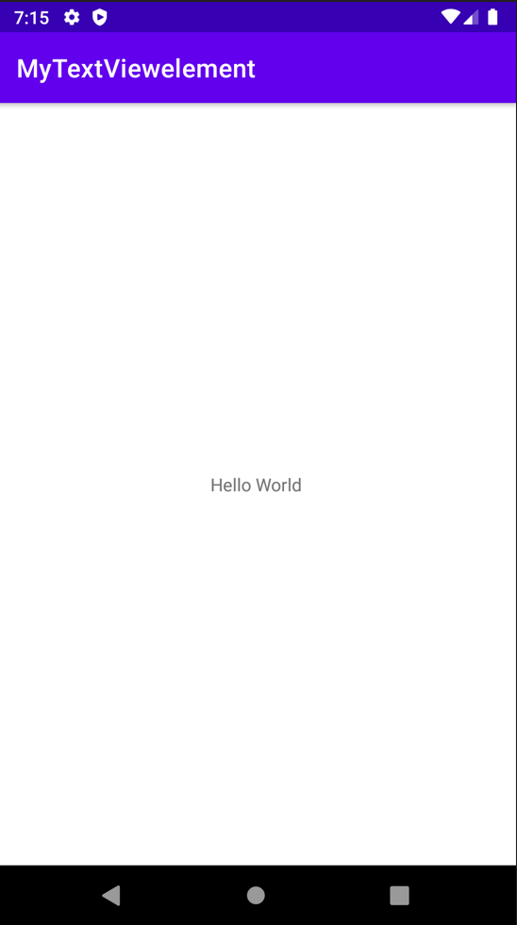

### **1. Formatting the TextView**

***Android offers mainly 3 types of typefaces***

* *normal*
* *sans*
* *serif*
* *monospace*
* The above four types of faces are to be invoked under the “**typeFace”** attribute of the TextView in XML.
* Invoke the following code and note the “**typeFace”**attribute of the TextView.

**Code: -**

<?xmlversion="1.0"encoding="utf-8"?>

<androidx.constraintlayout.widget.ConstraintLayout

    xmlns:android="<http://schemas.android.com/apk/res/android>"

    xmlns:app="<http://schemas.android.com/apk/res-auto>"

    xmlns:tools="<http://schemas.android.com/tools>"

    android:layout_width="match_parent"

    android:layout_height="match_parent"

    tools:context=".MainActivity"

    tools:ignore="HardcodedText">

    <!--the below typeFace attribute has to

         invoked with values mentioned-->

    <TextView

        android:layout_width="wrap_content"

        android:layout_height="wrap_content"

        android:text="Hello Public"

        android:textSize="32sp"

        android:typeface="normal"

        app:layout_constraintBottom_toBottomOf="parent"

        app:layout_constraintLeft_toLeftOf="parent"

        app:layout_constraintRight_toRightOf="parent"

        app:layout_constraintTop_toTopOf="parent"/>

</androidx.constraintlayout.widget.ConstraintLayout>

**Output:**

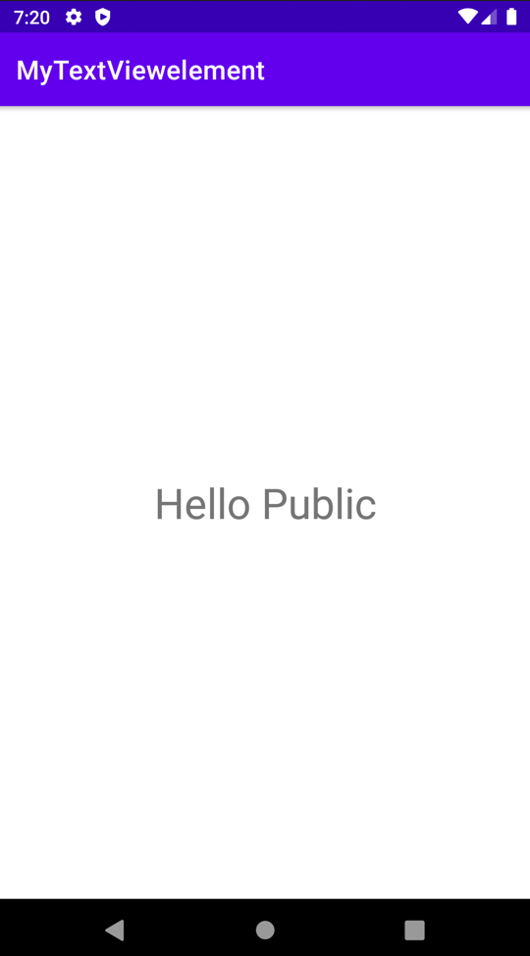

### **2. Size of the TextView**

* This feature of the Text view upholds what type of content has to be shown to the user. For example, if there is a Heading, there are 6 types of heading that can be implemented have a look at the following image which contains the guidelines for the size of the text view and style of the text view which is recommended by Google’s Material Design.

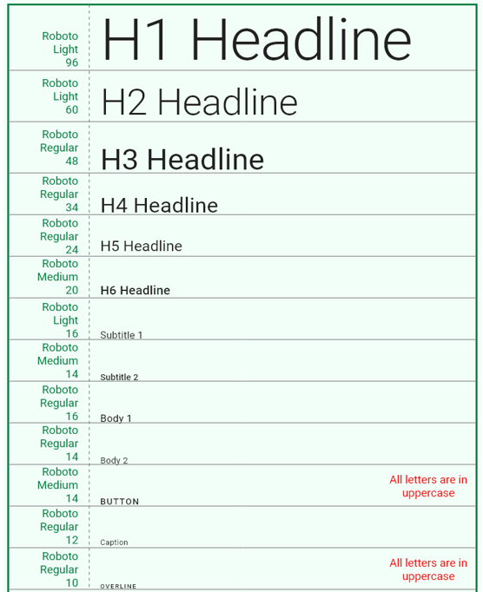

* The attribute which is used to change the size of the Text View in android is **“textSize”.**
* Refer to the following code and its output for better understanding.

**Code: -**

<?xmlversion="1.0"encoding="utf-8"?>

<LinearLayout

    xmlns:android="<http://schemas.android.com/apk/res/android>"

    xmlns:tools="<http://schemas.android.com/tools>"

    android:layout_width="match_parent"

    android:layout_height="match_parent"

    android:orientation="vertical"

    tools:context=".MainActivity"

    tools:ignore="HardcodedText">

    <TextView

        android:layout_width="wrap_content"

        android:layout_height="wrap_content"

        android:layout_marginStart="32dp"

        android:layout_marginTop="64dp"

        android:textSize="48sp"

        android:text="H3 Heading"/>

    <TextView

        android:layout_width="wrap_content"

        android:layout_height="wrap_content"

        android:layout_marginStart="32dp"

        android:layout_marginTop="32dp"

        android:textSize="32sp"

        android:text="H6 Heading"/>

    <TextView

        android:layout_width="wrap_content"

        android:layout_height="wrap_content"

        android:layout_marginStart="32dp"

        android:layout_marginTop="32dp"

        android:textSize="16sp"

        android:text="Body 1"/>

    <TextView

        android:layout_width="wrap_content"

        android:layout_height="wrap_content"

        android:layout_marginStart="32dp"

        android:layout_marginTop="32dp"

        android:textSize="14sp"

        android:text="Body 2"/>

</LinearLayout>

**Output:**

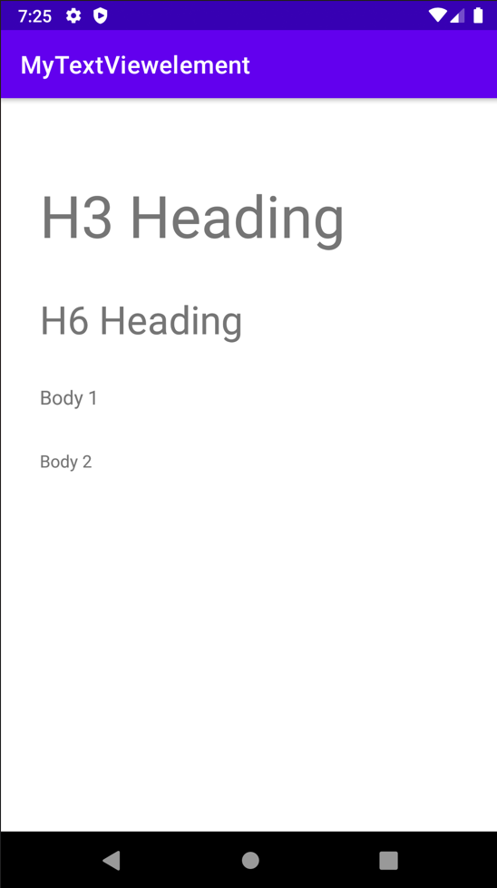

### **3. Changing Text Style**

***In Android there are basically three text styles:***

* *Bold*
* *Italic*
* *Normal*
* The text style of the text in android can be implemented using the attribute **“textStyle”.**
* Multiple text styles can also be implemented using the pipeline operator. Example **“android:textStyle=”bold|italic”.**
* To implement the various text styles refer to the following code and its output.

**Code: -**

<?xmlversion="1.0"encoding="utf-8"?>

<LinearLayout

    xmlns:android="<http://schemas.android.com/apk/res/android>"

    xmlns:tools="<http://schemas.android.com/tools>"

    android:layout_width="match_parent"

    android:layout_height="match_parent"

    tools:context=".MainActivity"

    tools:ignore="HardcodedText">

    <LinearLayout

        android:layout_width="match_parent"

        android:layout_height="wrap_content"

        android:layout_marginStart="32dp"

        android:layout_marginTop="32dp"

        android:orientation="vertical">

        <!--the below textStyle attribute has to

            invoked with values mentioned-->

        <TextView

            android:layout_width="wrap_content"

            android:layout_height="wrap_content"

            android:text="TCSC World

            android:textStyle="italic"

            android:textSize="32sp"/>

        <TextView

            android:layout_width="wrap_content"

            android:layout_height="wrap_content"

            android:layout_marginTop="32dp"

            android:text="TCSC World"

            android:textStyle="bold"

            android:textSize="32sp"/>

        <TextView

            android:layout_width="wrap_content"

            android:layout_height="wrap_content"

            android:layout_marginTop="32dp"

            android:text="TCSC World"

            android:textStyle="normal"

            android:textSize="32sp"/>

        <TextView

            android:layout_width="wrap_content"

            android:layout_height="wrap_content"

            android:layout_marginTop="32dp"

            android:text="TCSC World"

            android:textStyle="bold|italic"

            android:textSize="32sp"/>

    </LinearLayout>

</LinearLayout>

**Output:**

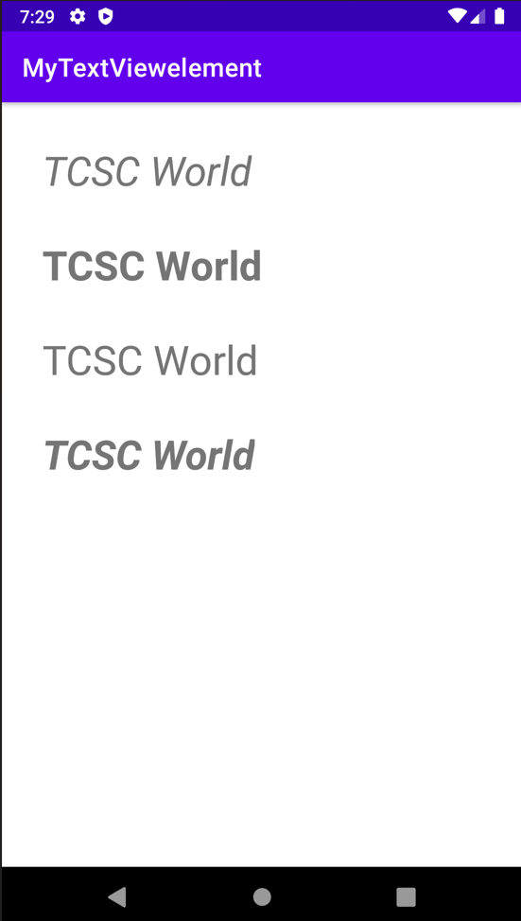

### **4. Changing the Text Color**

* The color of the text should also change according to the change in the context of the information displayed to the user.
* For example, if there is warning text it must be in the red color and for disabled text, the opacity or the text color should be grayish. To change the color of the text, the attribute **“textColor”** is used.
* Android also offers the predefined text colors, which can be implemented using **“@android:color/yourColor”**as value for the **“textColor”**. Here the value may be hex code or the predefined colors offered by the android.
* Refer to the following code and its output for better understanding.

**Code: -**

<?xmlversion="1.0"encoding="utf-8"?>

<LinearLayout

    xmlns:android="<http://schemas.android.com/apk/res/android>"

    xmlns:tools="<http://schemas.android.com/tools>"

    android:layout_width="match_parent"

    android:layout_height="match_parent"

    android:orientation="vertical"

    tools:context=".MainActivity"

    tools:ignore="HardcodedText">

    <!--the value predefined by android-->

    <TextView

        android:id="@+id/text"

        android:layout_width="wrap_content"

        android:layout_height="wrap_content"

        android:layout_marginStart="32dp"

        android:layout_marginTop="64dp"

        android:text="Warning Message"

        android:textColor="#B00020"

        android:textSize="32sp"/>

    <!--the value predefined by android-->

    <TextView

        android:layout_width="wrap_content"

        android:layout_height="wrap_content"

        android:layout_marginStart="32dp"

        android:layout_marginTop="16dp"

        android:text="Disabled Text"

        android:textColor="@android:color/darker_gray"

        android:textSize="32sp"/>

    <!--the value is hex code-->

    <TextView

        android:layout_width="wrap_content"

        android:layout_height="wrap_content"

        android:layout_marginStart="32dp"

        android:layout_marginTop="16dp"

        android:text="Hello World"

        android:textColor="#000000"

        android:textSize="32sp"/>

</LinearLayout>

**Output:**

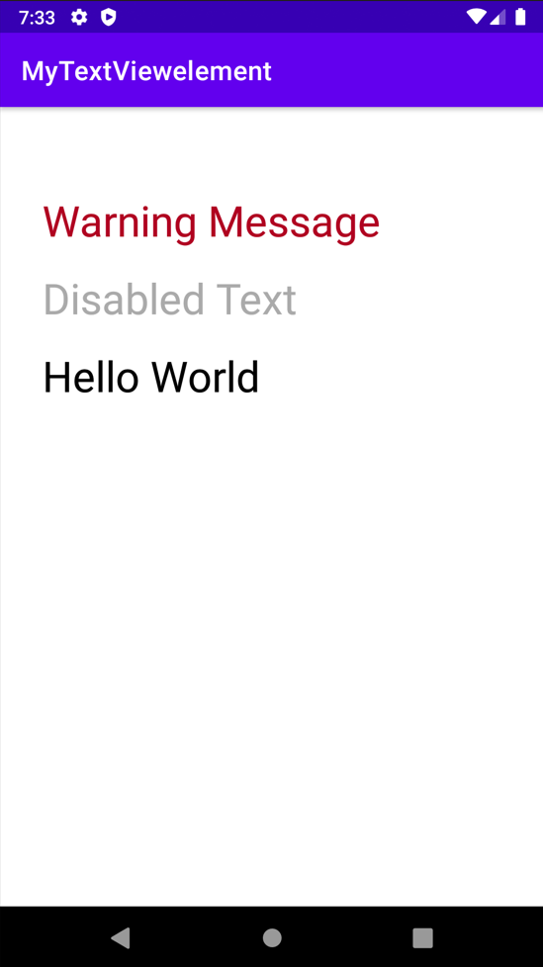

### **5. Letter Spacing and All Caps**

* Letter spacing and capital letters are some of the important properties of the text View in android.
* For the text of buttons and tab layouts, the text should be in uppercase letters recommended by Google Material Design.
* The letter spacing also should be maintained according to the scenario.
* Refer to the following code and its output for better understanding.

**Code: -**

<?xml version="1.0" encoding="utf-8"?>

<LinearLayout

xmlns:android="http://schemas.android.com/apk/res/android"

xmlns:tools="http://schemas.android.com/tools"

android:layout_width="match_parent"

android:layout_height="match_parent"

android:orientation="vertical"

tools:context=".MainActivity"

tools:ignore="HardcodedText">

<TextView

android:layout_width="wrap_content"

android:layout_height="wrap_content"

android:layout_marginStart="32dp"

android:layout_marginTop="64dp"

android:letterSpacing="0.15"

android:text="GeeksforGeeks"

android:textColor="@android:color/black"

android:textSize="32sp" />

<TextView

android:layout_width="wrap_content"

android:layout_height="wrap_content"

android:layout_marginStart="32dp"

android:layout_marginTop="64dp"

android:text="GeeksforGeeks"

android:textAllCaps="true"

android:textColor="@android:color/black"

android:textSize="32sp" />

</LinearLayout>

**Output:**

